|  |
| --- |
| **1. Project Members:** |

**i.** [Tanmoy Mazumder](mailto:19101013@uap-bd.edu) -19101013

ii. [Ali Mostakin Alvi](mailto:19101015@uap-bd.edu) -19101015

iii. [Shawan Das](mailto:19101020@uap-bd.edu) -19101020

|  |
| --- |
| **2. Objective:** |

The objective of this project is to establish a system in our country that allows tourists to find and book local tour guides online. The fundamental objective here is to create a seamless interaction method between the tourists and the guides. Additionally to this, there also would be a blog portion of the website where reviews of potential tour places would be published, enabling other tourists to check out reviews of places they may want to visit.

|  |
| --- |
| **3. Motivation:** |

The country of impeccable scenic natural beauty, Bangladesh, has an abundance of beautiful places to be visited. However, this country is not being able to fully utilize its potential to become a land filled with tourist attractions. A major barrier that’s preventing this is the tourists not knowing enough about the places, and not having access to anyone reliable to show them around, guiding them throughout the area. In a general situation, this would surely be tough as to go to a random destination and then find a reliable guide. Along with this comes the concern of security in an unfamiliar place. Finally, the problem that’s prominent is the transaction between the guide and the tourist. This is why a system that would solve all of these problems, would prove to be tremendously beneficial. With this goal in mind this system has carefully been curated to meet every need of this sector.

|  |
| --- |
| **4. Critical Challenges:** |

Working with complex ER Diagrams, UML Diagrams and Data Flow Diagrams, using new as well as implementing them in a project would be the most critical challenge as this is the first time these concepts are being introduced to the team members.

|  |
| --- |
| **5. Clients:** |

Clients of this system would be of three kinds: The tourists, the guides, and the brands that wish to advertise on the website. The tourists would easily find places to visit along with guides, the guides would find customers, and brands would advertise their products on the website. As all of them would be using the site, and through each of them the site would be earning, they’re all clients of this system.

|  |
| --- |
| **6. User:** |

For this particular system, the clients are also the users, along with the bloggers who’ll write tour blogs on the site.

**7. How Ks are addressed through the Project:**

|  |  |  |
| --- | --- | --- |
| **Ks** | **Attribute** | **How Ks are Addressed through the Project** |
| K1 | **Science:** theory-based understanding of the natural science applicable to the discipline. | We have to ensure that only trusted and verified people can provide services so that users/clients get better service and enjoy their trip. Also, we have ensured proper security of users. |
| K3 | **Eng. Fundamentals:** a systematic, theory-based formulation of engineering fundamentals required in the engineering discipline. | To provide better services and better tour experience, we tried to add safe tourist places. Users and guides can review places and share their experiences by Blogging about Tourist places. They can also contact us if they face any kind of problems. |
| K5 | **Eng. Design:**  Knowledge that supports engineering design in a practical area. | To implement this project, we had to design a database, the relation between entities so that our database could work functionally. |
| K6 | **Eng. Practice:** practice areas in the engineering discipline. | In this project, we have to work with proper discipline and planning. We also learned the basic steps of creating a proper project. |

**8. How Ps are addressed through the project among Ps,COs, and POs:**

|  |  |  |
| --- | --- | --- |
| **Ps** | **Attribute** | **How Ps are Addressed through the Project** |
| P1 | **Depth of Knowledge Required:** Cannot be resolved without in-depth engineering knowledge at the level of one or more of K3, K4, K5, K6 or K8 which allows a fundamentals-based, first principal analytical approach | This project requires rigorous study of all existing “Tour Guide Providing Service” **(K8),** survey stakeholders - Tour-guide, user, monitoring authority **(K3, K4)**, web-based backend, frontend design **(K5, K6)**. |
| P3 | **Depth of Analysis Required:** Have no obvious solution and require abstract thinking, originality in analysis to formulate suitable models | Dept of analysis of requirements from user, guide, monitoring authority is needed to ensure user satisfaction. |
| P4 | **Extent of applicable codes:**  are outside problems encompassed by standards and codes of practice for professional engineering. | This project is required to analyze and implement various programming knowledge and skills. |
| P7 | **Interdependence:** Are high-level problems including many components parts or sub-problems | Our project involves interdependent components such as requirement analysis, designing back-end, front-end, software testing etc. |

## Designing Phase

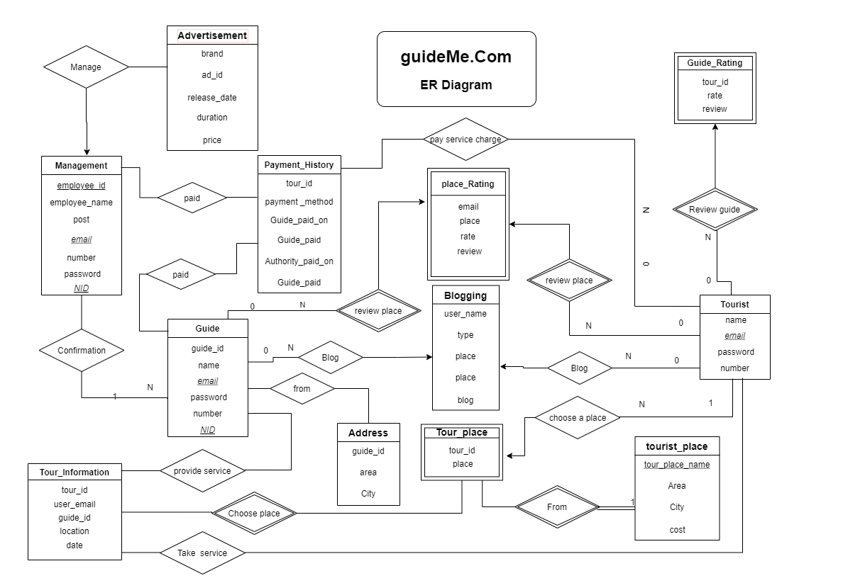

**DFD Diagram**

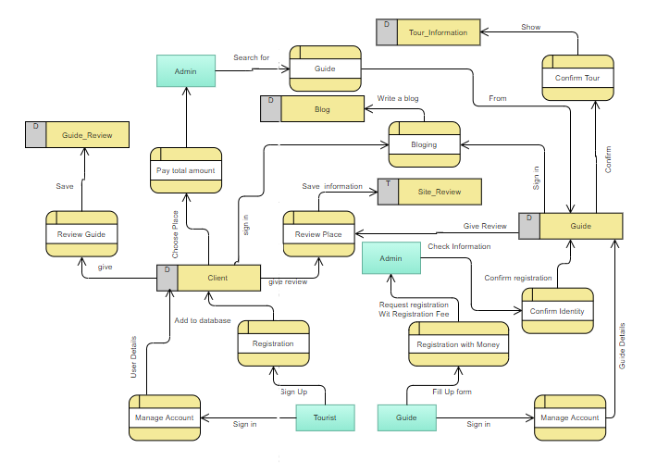

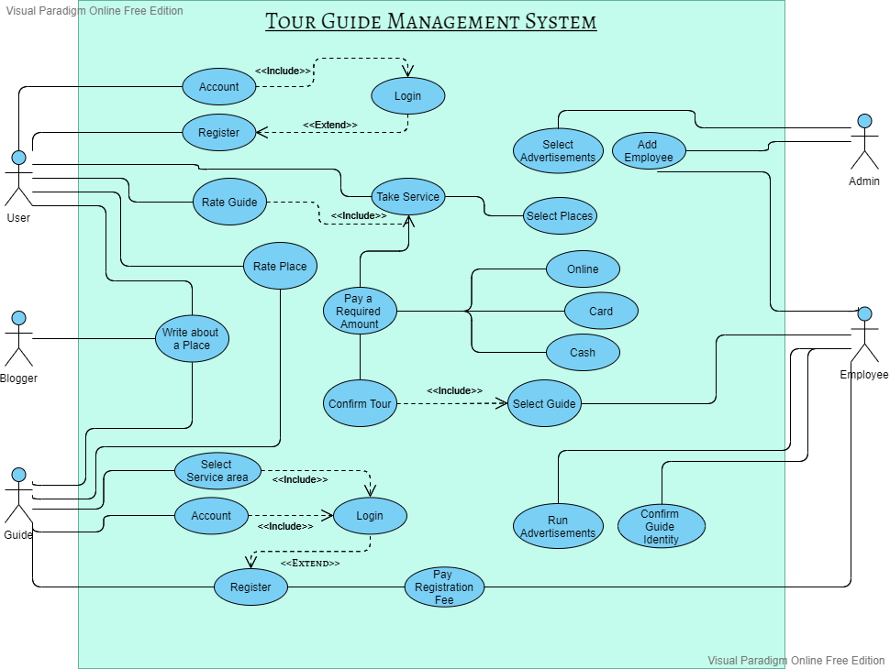**USE CASE DIAGRAM**

**Methodology:**  Waterfall Methodology

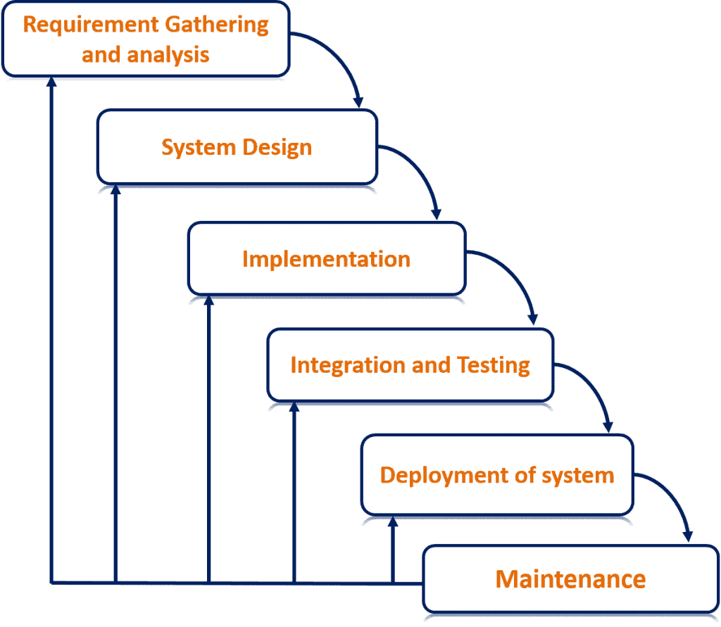

**9. How As are addressed through the project:**

|  |  |  |
| --- | --- | --- |
| **As** | **Attribute** | **How As are Addressed through the Project** |
| A1 | **Range of Resources:** Involve the use of derived resources. | Our project needs to engage diverse resources including various designing tools. |
| A2 | **Level of Interaction:** require resolution of significant problems arising from interactions between wide-ranging or conflicting technical, engineering or other issues. | A good level of interaction is needed among the user and tour guides. |
| A3 | **Innovation:** Involve creative use of engineering principles and research-based knowledge in novel ways | Our platform needs to be updated with innovative and creative ideas to meet the feedback from all user, tourist-guide & monitoring authorities. |
| A4 | **Consequence of society & Environment:** Have significant consequences in a range of contexts, characterized by difficulty of prediction & mitigation. | Adult people like students who likes to travel, can earn money |

***CO-PO Mapping of CSE 306(System Analysis & Design Lab):***

|  |  |
| --- | --- |
| **CO-PO** | **Assessment Tool** |
| CO1-PO(a) Engineering Knowledge | Lab Performance |
| CO2-PO (c) Design/ Development of solutions | Presentation & Documentation |
| CO3-PO (e) Modern Tool usage  CO3-PO(i) Individual & Team work | Lab Performance  Presentation & Project update |
| CO4-PO (f)- The engineering & society  CO4-PO (h)- Ethics  CO4-PO (j)- Communication  CO4-PO(k)- Project Management & Finance  CO4-PO(l)- Lifelong Learning | Project & Documentation  Viva & Project Documentation (Motivation & business plan)  Presentation  Documentation  Viva (Describing a relevant scenario & taking the response of the student) |